

**Project Phase #2**

**Course:**

Database Management System

**Topic:**

Train Management System

**Submitted by:**

|  |  |
| --- | --- |
| **Roll No.** | **Name** |
| 22F-3708 | Syed Muhammad Taqi |
| 22F-3722 | Muhammad Abdullah |
|  |  |
|  |  |
|  |  |

**Submitted to:**

Ma’am Samia Aziz

**LOGIN PAGE**using System;

using System.Collections.Generic;

using System.ComponentModel;

using System.Data;

using System.Drawing;

using System.Linq;

using System.Security.AccessControl;

using System.Text;

using System.Threading.Tasks;

using System.Windows.Forms;

using Oracle.ManagedDataAccess.Client;

namespace GROUP_2

{

public partial class Form1 : Form

{

public Form1()

{

InitializeComponent();

}

private void button1_Click(object sender, EventArgs e)

{

string email = UsernameBox.Text;

string password = PasswordBox.Text;

string accountType = choice.Text;

String connectionString = @"DATA SOURCE =localhost:1521/XE;USER ID =F223722; PASSWORD=f223722";

admin adobj = new admin();

passenger psobj = new passenger();

employee empobj = new employee();

adobj.sendCredentials(UsernameBox.Text, choice.Text);

empobj.sendCredentials(UsernameBox.Text, choice.Text);

psobj.sendCredentials(UsernameBox.Text, choice.Text);

using (OracleConnection connection = new OracleConnection(connectionString))

{

try

{

connection.Open();

if (accountType == "Admin")

{

string sqlQuery = "SELECT COUNT(*) FROM ADMIN WHERE EMAIL = :email AND PASSWORD = :password AND ACCOUNT_TYPE = :accountType";

using (OracleCommand command = new OracleCommand(sqlQuery, connection))

{

command.Parameters.Add(new OracleParameter("email", email));

command.Parameters.Add(new OracleParameter("password", password));

command.Parameters.Add(new OracleParameter("accountType", accountType));

int count = Convert.ToInt32(command.ExecuteScalar());

if (count > 0)

{

adobj.ShowDialog();

}

connection.Close();

}

}

else if (accountType == "Passenger")

{

string sqlQuery = "SELECT COUNT(*) FROM PASSENGER WHERE EMAIL = :email AND PASSWORD = :password AND ACCOUNT_TYPE = :accountType";

using (OracleCommand command = new OracleCommand(sqlQuery, connection))

{

command.Parameters.Add(new OracleParameter("email", email));

command.Parameters.Add(new OracleParameter("password", password));

command.Parameters.Add(new OracleParameter("accountType", accountType));

int count = Convert.ToInt32(command.ExecuteScalar());

if (count > 0)

{

psobj.ShowDialog();

}

connection.Close();

}

}

else

{

string sqlQuery = "SELECT COUNT(*) FROM EMPLOYEE WHERE EMAIL = :email AND PASSWORD = :password AND ACCOUNT_TYPE = :accountType";

using (OracleCommand command = new OracleCommand(sqlQuery, connection))

{

command.Parameters.Add(new OracleParameter("email", email));

command.Parameters.Add(new OracleParameter("password", password));

command.Parameters.Add(new OracleParameter("accountType", accountType));

int count = Convert.ToInt32(command.ExecuteScalar());

if (count > 0)

{

empobj.ShowDialog();

}

connection.Close();

}

}

}

catch (Exception ex)

{

MessageBox.Show("Error: " + ex.Message);

}

}

}

private void comboBox1_SelectedIndexChanged(object sender, EventArgs e)

{

}

private void label1_Click(object sender, EventArgs e)

{

}

private void textBox2_TextChanged(object sender, EventArgs e)

{

}

private void username_Click(object sender, EventArgs e)

{

}

private void button1_Click_1(object sender, EventArgs e)

{

signUP obj = new signUP();

obj.ShowDialog();

}

private void label1_Click_1(object sender, EventArgs e)

{

}

private void pictureBox1_Click(object sender, EventArgs e)

{

}

private void Form1_Load(object sender, EventArgs e)

{

}

private void UsernameBox_TextChanged(object sender, EventArgs e)

{

}

}

}

**SIGN UP**using System;

using System.Collections.Generic;

using System.ComponentModel;

using System.Data;

using System.Drawing;

using System.Linq;

using System.Text;

using System.Threading.Tasks;

using System.Windows.Forms;

namespace GROUP_2

{

public partial class signUP : Form

{

public signUP()

{

InitializeComponent();

}

private void label1_Click(object sender, EventArgs e)

{

}

private void button1_Click(object sender, EventArgs e)

{

Form1 obj = new Form1();

obj.ShowDialog();

}

private void signUPButton_Click(object sender, EventArgs e)

{

Form1 obj = new Form1();

obj.ShowDialog();

}

private void signUP_Load(object sender, EventArgs e)

{

}

}

}

**EMPLOYEE CLASS**  
using System;

using System.Data;

using Oracle.ManagedDataAccess.Client;

public class empDBMS

{

public int EmployeeID { get; set; }

public string Name { get; set; }

public string Email { get; set; }

public string Password { get; set; }

public string PhoneNumber { get; set; }

public string category { get; set; }

public string Task { get; set; }

public decimal Salary { get; set; }

public string Address { get; set; }

public string CNIC { get; set; }

string connectionString = @"DATA SOURCE=localhost:1521/XE;USER ID=F223722; PASSWORD = f223722";

public void addEMP()

{

using (OracleConnection connection = new OracleConnection(connectionString))

{

string query = "INSERT INTO F223722.EMPLOYEE (EmployeeID, Name, Email, Password, PhoneNumber, Role, Tasks, Salary, Address, CNIC) VALUES (:EmployeeID, :Name, :Email, :Password, :PhoneNumber, :Role, :Task, :Salary, :Address, :CNIC)";

OracleCommand command = new OracleCommand(query, connection);

command.Parameters.Add(":EmployeeID", EmployeeID);

command.Parameters.Add(":Name", Name);

command.Parameters.Add(":Email", Email);

command.Parameters.Add(":Password", Password);

command.Parameters.Add(":PhoneNumber", PhoneNumber);

command.Parameters.Add(":Role", category);

command.Parameters.Add(":Tasks", Task);

command.Parameters.Add(":Salary", Salary);

command.Parameters.Add(":Address", Address);

command.Parameters.Add(":CNIC", CNIC);

connection.Open();

command.ExecuteNonQuery();

}

}

public void updateEMP()

{

using (OracleConnection connection = new OracleConnection(connectionString))

{

string query = "UPDATE F223722.Employee SET Name = :Name, Email = :Email, Password = :Password, PhoneNumber = :PhoneNumber, Role = :Role,Tasks = :Tasks, Salary = :Salary, Address = :Address, CNIC = :CNIC WHERE EmployeeID = :EmployeeID";

OracleCommand command = new OracleCommand(query, connection);

command.Parameters.Add(":Name", Name);

command.Parameters.Add(":Email", Email);

command.Parameters.Add(":Password", Password);

command.Parameters.Add(":PhoneNumber", PhoneNumber);

command.Parameters.Add(":Role", category);

command.Parameters.Add(":Tasks", Task);

command.Parameters.Add(":Salary", Salary);

command.Parameters.Add(":Address", Address);

command.Parameters.Add(":CNIC", CNIC);

command.Parameters.Add(":EmployeeID", EmployeeID);

connection.Open();

command.ExecuteNonQuery();

}

}

public void assignTask()

{

using (OracleConnection connection = new OracleConnection(connectionString))

{

string query = "UPDATE F223722.Employee SET Tasks = :Tasks";

OracleCommand command = new OracleCommand(query, connection);

command.Parameters.Add(":Tasks", Task);

connection.Open();

command.ExecuteNonQuery();

}

}

public void deleteEMP(int employeeID)

{

using (OracleConnection connection = new OracleConnection(connectionString))

{

string query = "DELETE FROM Employees WHERE EmployeeID = :EmployeeID";

OracleCommand command = new OracleCommand(query, connection);

command.Parameters.Add(":EmployeeID", employeeID);

connection.Open();

command.ExecuteNonQuery();

}

}

public DataTable RetriveEMP()

{

DataTable dataTable = new DataTable();

using (OracleConnection connection = new OracleConnection(connectionString))

{

string query = "SELECT EmployeeID, Name, Email, Password, Role, Tasks, Salary, Address, PHONENUMBER, CNIC FROM F223722.Employee";

OracleDataAdapter adapter = new OracleDataAdapter(query, connection);

adapter.Fill(dataTable);

}

return dataTable;

}

public DataTable RETRIVEbyID(int employeeID)

{

DataTable dataTable = new DataTable();

using (OracleConnection connection = new OracleConnection(connectionString))

{

string query = "SELECT EmployeeID, Name, Email, Password, PhoneNumber, Role, Tasks, Salary, Address, CNIC FROM F223722.Employee WHERE EmployeeID = :employeeID";

OracleDataAdapter adapter = new OracleDataAdapter(query, connection);

adapter.SelectCommand.Parameters.Add(":EmployeeID", employeeID);

adapter.Fill(dataTable);

}

return dataTable;

}

}

**Train Class**using System;

using System.Data;

using Oracle.ManagedDataAccess.Client;

public class TrainDBMS

{

string connectionString = @"DATA SOURCE=localhost:1521/XE;USER ID=F223722; PASSWORD = f223722";

public void addTrain( string trainName,DateTime departureTime, DateTime arrivalTime, string route, string departure, string destination, int capacity, decimal fare, string status)

{

using (OracleConnection connection = new OracleConnection(connectionString))

{

string query = @"INSERT INTO Train (TRAIN_NAME, DEPARTURE_TIME, ARRIVAL_TIME, ROUTE, DEPARTURE, DESTINATION, CAPACITY, FARE, STATUS)

VALUES (:TrainName, :DepartureTime, :ArrivalTime, :Route, :Departure, :Destination, :Capacity, :Fare, :Status)";

OracleCommand command = new OracleCommand(query, connection);

command.Parameters.Add(":TrainName", trainName);

command.Parameters.Add(":DepartureTime", departureTime);

command.Parameters.Add(":ArrivalTime", arrivalTime);

command.Parameters.Add(":Route", route);

command.Parameters.Add(":Departure", departure);

command.Parameters.Add(":Destination", destination);

command.Parameters.Add(":Capacity", capacity);

command.Parameters.Add(":Fare", fare);

command.Parameters.Add(":Status", status);

connection.Open();

command.ExecuteNonQuery();

}

}

public void UpdateTrain(int trainID, string trainName, DateTime departureTime, DateTime arrivalTime, string route, string departure, string destination, int capacity, decimal fare, string status)

{

using (OracleConnection connection = new OracleConnection(connectionString))

{

string query = @"UPDATE Train

SET TRAIN_NAME = :trainName,

DEPARTURE_TIME = :departureTime,

ARRIVAL_TIME = :arrivalTime,

ROUTE = :toute,

DEPARTURE = :departure,

DESTINATION = :destination,

CAPACITY = :capacity,

FARE = :fare,

STATUS = :Status

WHERE TRAIN_ID = :trainID";

OracleCommand command = new OracleCommand(query, connection);

command.Parameters.Add(":TrainName", trainName);

command.Parameters.Add(":DepartureTime", departureTime);

command.Parameters.Add(":ArrivalTime", arrivalTime);

command.Parameters.Add(":Route", route);

command.Parameters.Add(":Departure", departure);

command.Parameters.Add(":Destination", destination);

command.Parameters.Add(":Capacity", capacity);

command.Parameters.Add(":Fare", fare);

command.Parameters.Add(":Status", status);

command.Parameters.Add(":TrainID", trainID);

connection.Open();

command.ExecuteNonQuery();

}

}

public DataTable RetrieveTrain()

{

DataTable dataTable = new DataTable();

using (OracleConnection connection = new OracleConnection(connectionString))

{

string query = "SELECT * FROM F223722.Train";

OracleDataAdapter adapter = new OracleDataAdapter(query, connection);

adapter.Fill(dataTable);

}

return dataTable;

}

public DataTable retrieveTrainByID(int trainID)

{

DataTable dataTable = new DataTable();

using (OracleConnection connection = new OracleConnection(connectionString))

{

string query = "SELECT TRAIN_ID, TRAIN_NAME, DEPARTURE, DESTINATION, ROUTE, DEPARTURE_TIME, ARRIVAL_TIME, CAPACITY, FARE, STATUS FROM Train WHERE TRAIN_ID = :trainID";

OracleDataAdapter adapter = new OracleDataAdapter(query, connection);

adapter.SelectCommand.Parameters.Add(":TrainID", trainID);

adapter.Fill(dataTable);

}

return dataTable;

}

public void deleteTrain(int trainID)

{

using (OracleConnection connection = new OracleConnection(connectionString))

{

string query = "DELETE FROM Train WHERE TRAIN_ID = :TrainID";

OracleCommand command = new OracleCommand(query, connection);

command.Parameters.Add(":TrainID", trainID);

connection.Open();

command.ExecuteNonQuery();

}

}

}

**ADMIN DASHBOARD**using System;

using System.Collections.Generic;

using System.ComponentModel;

using System.Data;

using System.Drawing;

using System.Linq;

using System.Text;

using System.Threading.Tasks;

using System.Windows.Forms;

namespace GROUP_2

{

public partial class admin : Form

{

string email, accT;

public admin()

{

InitializeComponent();

}

private void button6_Click(object sender, EventArgs e)

{

ManageTrainSchedule obj = new ManageTrainSchedule();

obj.ShowDialog();

}

private void button4_Click(object sender, EventArgs e)

{

}

private void button1_Click(object sender, EventArgs e)

{

feedback obj = new feedback();

obj.ShowDialog();

}

private void mngEmployees_Click(object sender, EventArgs e)

{

manageEmployees obj = new manageEmployees();

obj.ShowDialog();

}

private void checkProfile_Click(object sender, EventArgs e)

{

adminProfile obj = new adminProfile();

obj.sendCredentials(email, accT);

obj.ShowDialog();

}

private void viewTrains_Click(object sender, EventArgs e)

{

viewTrains obj = new viewTrains();

obj.ShowDialog();

}

private void assignTask_Click(object sender, EventArgs e)

{

manageEmployees obj = new manageEmployees();

obj.ShowDialog();

}

public void sendCredentials(string emailF,string accTF)

{

email = emailF;

accT = accTF;

}

private void admin_Load(object sender, EventArgs e)

{

}

}

}

**ADMIN PROFILE CHECK**using System;

using System.Collections.Generic;

using System.ComponentModel;

using System.Data;

using System.Drawing;

using System.Linq;

using System.Net;

using System.Text;

using System.Threading.Tasks;

using System.Windows.Forms;

using Oracle.ManagedDataAccess.Client;

namespace GROUP_2

{

public partial class adminProfile : Form

{

string emailCred, accTF;

String connectionString = @"DATA SOURCE =localhost:1521/XE;USER ID =F223722; PASSWORD=f223722";

public adminProfile()

{

InitializeComponent();

}

private void adminProfile_Load(object sender, EventArgs e)

{

if (accTF == "Admin")

{

string query = $"SELECT * FROM F223722.ADMIN WHERE EMAIL ='{emailCred}'";

using (OracleConnection connection = new OracleConnection(connectionString))

{

using (OracleCommand command = new OracleCommand(query, connection))

{

try

{

connection.Open();

OracleDataReader reader = command.ExecuteReader();

if (reader.Read())

{

namebox.Text = reader["NAME"].ToString();

emailBox.Text = reader["EMAIL"].ToString();

cnicBOX.Text = reader["CNIC"].ToString();

genderBox.Text = reader["GENDER"].ToString();

contactBox.Text = reader["PHONENUMBER"].ToString();

cityBox.Text = reader["ADDRESS"].ToString();

}

else

{

MessageBox.Show("No data found for the provided User ID.", "Error", MessageBoxButtons.OK, MessageBoxIcon.Error);

}

}

catch (Exception ex)

{

MessageBox.Show("An error occurred: " + ex.Message, "Error", MessageBoxButtons.OK, MessageBoxIcon.Error);

}

}

}

}

}

private void update_Click(object sender, EventArgs e)

{

string cnic = cnicBOX.Text;

string Name = namebox.Text;

string email = emailBox.Text;

string address = cityBox.Text;

string gender = genderBox.Text;

string phoneNumber = contactBox.Text;

string query = $"UPDATE F223722.ADMIN SET Name = '{Name}', Email = '{email}', Address = '{address}',PhoneNumber = '{phoneNumber}', Gender = '{gender}', CNIC = '{cnic}' WHERE EMAIL = '{email}'";

using (OracleConnection connection = new OracleConnection(connectionString))

{

using (OracleCommand command = new OracleCommand(query, connection))

{

try

{

connection.Open();

int rowsAffected = command.ExecuteNonQuery();

if (rowsAffected > 0)

{

MessageBox.Show("Records updated successfully.", "Success", MessageBoxButtons.OK, MessageBoxIcon.Information);

}

else

{

MessageBox.Show("No records updated. EMPLOYEE ID not found.", "Error", MessageBoxButtons.OK, MessageBoxIcon.Error);

}

}

catch (Exception ex)

{

MessageBox.Show("An error occurred: " + ex.Message, "Error", MessageBoxButtons.OK, MessageBoxIcon.Error);

}

}

}

}

public void sendCredentials(string email, string accT)

{

emailCred = email;

accTF = accT;

}

}

}

**MANAGE EMPLOYEES**using System;

using System.Collections.Generic;

using System.ComponentModel;

using System.Data;

using System.Drawing;

using System.Linq;

using System.Net;

using System.Text;

using System.Threading.Tasks;

using System.Windows.Forms;

using static System.Windows.Forms.VisualStyles.VisualStyleElement.ListView;

using Oracle.ManagedDataAccess.Client;

namespace GROUP_2

{

public partial class manageEmployees : Form

{

empDBMS empDBMSobj = new empDBMS();

public manageEmployees()

{

InitializeComponent();

}

private void employeesView_CellContentClick(object sender, DataGridViewCellMouseEventArgs e)

{

}

private void manageEmployees_Load(object sender, EventArgs e)

{

DataTable dt = empDBMSobj.RetriveEMP();

employeesView.DataSource = dt;

}

private void search_Click(object sender, EventArgs e)

{

DataTable dt = empDBMSobj.RETRIVEbyID(int.Parse(inputBox.Text));

employeesView.DataSource = dt;

}

private void employeesView_RowHeaderMouseClick(object sender, DataGridViewCellMouseEventArgs e)

{

int rowIndex = e.RowIndex;

empIDbox.Text = employeesView.Rows[rowIndex].Cells[0].Value.ToString();

empNameBox.Text = employeesView.Rows[rowIndex].Cells[1].Value.ToString();

emailBox.Text = employeesView.Rows[rowIndex].Cells[2].Value.ToString();

passwordBox.Text = employeesView.Rows[rowIndex].Cells[3].Value.ToString();

categoryBox.Text = employeesView.Rows[rowIndex].Cells[4].Value.ToString();

taskbox.Text = employeesView.Rows[rowIndex].Cells[5].Value.ToString();

salaryBOX.Text = employeesView.Rows[rowIndex].Cells[6].Value.ToString();

addressBOX.Text = employeesView.Rows[rowIndex].Cells[7].Value.ToString();

contactBOX.Text = employeesView.Rows[rowIndex].Cells[8].Value.ToString();

cnic.Text = employeesView.Rows[rowIndex].Cells[9].Value.ToString();

}

private void Task_Click(object sender, EventArgs e)

{

}

private void add_Click(object sender, EventArgs e)

{

empDBMSobj.EmployeeID = int.Parse(empIDbox.Text);

empDBMSobj.Name = empNameBox.Text;

empDBMSobj.Email = emailBox.Text;

empDBMSobj.Password = passwordBox.Text;

empDBMSobj.PhoneNumber = contactBOX.Text;

empDBMSobj.category = categoryBox.Text;

empDBMSobj.Task = taskbox.Text;

empDBMSobj.Salary = decimal.Parse(salaryBOX.Text);

empDBMSobj.Address = addressBOX.Text;

empDBMSobj.CNIC = cnic.Text;

empDBMSobj.addEMP();

ReloadGRID();

}

private void ReloadGRID()

{

DataTable dt = empDBMSobj.RetriveEMP();

employeesView.DataSource = dt;

}

private void update_Click(object sender, EventArgs e)

{

empDBMSobj.EmployeeID = int.Parse(empIDbox.Text);

empDBMSobj.Name = empNameBox.Text;

empDBMSobj.Email = emailBox.Text;

empDBMSobj.Password = passwordBox.Text;

empDBMSobj.PhoneNumber = contactBOX.Text;

empDBMSobj.category = categoryBox.Text;

empDBMSobj.Task = taskbox.Text;

empDBMSobj.Salary = decimal.Parse(salaryBOX.Text);

empDBMSobj.Address = addressBOX.Text;

empDBMSobj.CNIC = cnic.Text;

empDBMSobj.updateEMP();

ReloadGRID();

}

private void delete_Click(object sender, EventArgs e)

{

empDBMSobj.deleteEMP(int.Parse(employeeID.Text));

ReloadGRID();

}

private void assignTask_Click(object sender, EventArgs e)

{

empDBMSobj.Task = taskbox.Text;

empDBMSobj.assignTask();

ReloadGRID();

}

private void employeesView_CellContentClick(object sender, DataGridViewCellEventArgs e)

{

}

}

}

**MANAGE TRAINS SCHEDULE**using System;

using System.Collections.Generic;

using System.ComponentModel;

using System.Data;

using System.Drawing;

using System.Linq;

using System.Net.NetworkInformation;

using System.Text;

using System.Threading.Tasks;

using System.Windows.Forms;

using Oracle.ManagedDataAccess.Client;

namespace GROUP_2

{

public partial class ManageTrainSchedule : Form

{

TrainDBMS trainDBMSobj= new TrainDBMS();

public ManageTrainSchedule()

{

InitializeComponent();

}

private void title_Click(object sender, EventArgs e)

{

}

private void dateTimePicker1_ValueChanged(object sender, EventArgs e)

{

}

private void button1_Click(object sender, EventArgs e)

{

string trainName = trainNameBox.Text;

DateTime departureTime = DateTime.Parse(depTimeBox.Text);

DateTime arrivalTime = DateTime.Parse(arrTimeBox.Text);

string route = routeBox.Text;

string departure = fromCity.Text;

string destination = toCity.Text;

int capacity = int.Parse(capacityBox.Text);

decimal fare = decimal.Parse(fareBox.Text);

string status = Statusbox.Text;

trainDBMSobj.addTrain( trainName,departureTime, arrivalTime, route, departure, destination, capacity, fare, status);

reloadPage();

}

public void reloadPage()

{

DataTable tableData = trainDBMSobj.RetrieveTrain();

trainscheduleView.DataSource = tableData;

}

private void button2_Click(object sender, EventArgs e)

{

int tID = int.Parse(trainIDbox.Text);

trainDBMSobj.deleteTrain(tID);

reloadPage();

}

private void trainNameBox_TextChanged(object sender, EventArgs e)

{

}

private void trainscheduleView_CellContentClick(object sender, DataGridViewCellEventArgs e)

{

}

private void ManageTrainSchedule_Load(object sender, EventArgs e)

{

reloadPage();

}

private void search_Click(object sender, EventArgs e)

{

DataTable tableData = trainDBMSobj.retrieveTrainByID(int.Parse(inputBox.Text));

trainscheduleView.DataSource = tableData;

}

private void trainscheduleView_RowHeaderMouseClick(object sender, DataGridViewCellMouseEventArgs e)

{

int rowIndex = e.RowIndex;

trainIDbox.Text = trainscheduleView.Rows[rowIndex].Cells[0].Value.ToString();

trainNameBox.Text = trainscheduleView.Rows[rowIndex].Cells[1].Value.ToString();

depTimeBox.Text = trainscheduleView.Rows[rowIndex].Cells[3].Value.ToString();

arrTimeBox.Text = trainscheduleView.Rows[rowIndex].Cells[4].Value.ToString();

routeBox.Text = trainscheduleView.Rows[rowIndex].Cells[5].Value.ToString();

fromCity.Text = trainscheduleView.Rows[rowIndex].Cells[6].Value.ToString();

toCity.Text = trainscheduleView.Rows[rowIndex].Cells[7].Value.ToString();

capacityBox.Text = trainscheduleView.Rows[rowIndex].Cells[8].Value.ToString();

fareBox.Text = trainscheduleView.Rows[rowIndex].Cells[9].Value.ToString();

Statusbox.Text = trainscheduleView.Rows[rowIndex].Cells[10].Value.ToString();

}

private void update_Click(object sender, EventArgs e)

{

string trainName = trainNameBox.Text;

DateTime departureTime = DateTime.Parse(depTimeBox.Text);

DateTime arrivalTime = DateTime.Parse(arrTimeBox.Text);

string route = routeBox.Text;

string departure = fromCity.Text;

string destination = toCity.Text;

int capacity = int.Parse(capacityBox.Text);

decimal fare = decimal.Parse(fareBox.Text);

string status = Statusbox.Text;

int trainID = int.Parse(trainIDbox.Text);

trainDBMSobj.UpdateTrain(trainID, trainName, departureTime, arrivalTime, route, departure, destination, capacity, fare, status);

reloadPage();

}

}

}

**VIEW TRAINS**using System;

using System.Collections.Generic;

using System.ComponentModel;

using System.Data;

using System.Drawing;

using System.Linq;

using System.Text;

using System.Threading.Tasks;

using System.Windows.Forms;

using Oracle.ManagedDataAccess.Client;

namespace GROUP_2

{

public partial class viewTrains : Form

{

TrainDBMS trainDBMSobj = new TrainDBMS();

String connectionString = @"DATA SOURCE =localhost:1521/XE;USER ID =F223722; PASSWORD=f223722";

public viewTrains()

{

InitializeComponent();

}

private void title_Click(object sender, EventArgs e)

{

}

private void taskDeadline_Click(object sender, EventArgs e)

{

}

private void assignTask_Click(object sender, EventArgs e)

{

trainView.DataSource = null;

DataTable dataTable = new DataTable();

string departure = fromCity.Text;

string arrival = toCity.Text;

DateTime Date1 = dateTimePicker1.Value.Date;

string query = "SELECT * FROM F223722.Train WHERE DEPARTURE = :departure AND DESTINATION = :arrival AND TRUNC(DEPARTURE_TIME) = :Date1";

using (OracleConnection connection = new OracleConnection(connectionString))

{

using (OracleCommand command = new OracleCommand(query, connection))

{

command.Parameters.Add(":departure", OracleDbType.Varchar2).Value = departure;

command.Parameters.Add(":arrival", OracleDbType.Varchar2).Value = arrival;

command.Parameters.Add(":Date1", OracleDbType.Date).Value = Date1;

connection.Open();

try

{

OracleDataReader reader = command.ExecuteReader();

dataTable.Load(reader);

trainView.DataSource = dataTable;

}

catch (Exception ex)

{

MessageBox.Show("Error: " + ex.Message, "Error", MessageBoxButtons.OK, MessageBoxIcon.Error);

}

}

}

}

private void delete_Click(object sender, EventArgs e)

{

}

private void update_Click(object sender, EventArgs e)

{

}

private void view_Click(object sender, EventArgs e)

{

}

private void add_Click(object sender, EventArgs e)

{

}

private void search_Click(object sender, EventArgs e)

{

}

private void label1_Click(object sender, EventArgs e)

{

}

private void inputBox_TextChanged(object sender, EventArgs e)

{

}

private void employeesView_CellContentClick(object sender, DataGridViewCellEventArgs e)

{

}

private void taskBox_TextChanged(object sender, EventArgs e)

{

}

private void empIDbox_TextChanged(object sender, EventArgs e)

{

}

private void empNameBox_TextChanged(object sender, EventArgs e)

{

}

private void categoryBox_TextChanged(object sender, EventArgs e)

{

}

private void Task_Click(object sender, EventArgs e)

{

}

private void arrivalCity_Click(object sender, EventArgs e)

{

}

private void employeeID_Click(object sender, EventArgs e)

{

}

private void employeeName_Click(object sender, EventArgs e)

{

}

private void dateTimePicker1_ValueChanged(object sender, EventArgs e)

{

}

private void pictureBox2_Click(object sender, EventArgs e)

{

}

private void label3_Click(object sender, EventArgs e)

{

}

private void toCity_SelectedIndexChanged(object sender, EventArgs e)

{

}

private void viewTrains_Load(object sender, EventArgs e)

{

trainView.DataSource = null;

DataTable dataTable = new DataTable();

string query = "SELECT * FROM F223722.Train";

using (OracleConnection connection = new OracleConnection(connectionString))

{

using (OracleCommand command = new OracleCommand(query, connection))

{

connection.Open();

try

{

OracleDataReader reader = command.ExecuteReader();

dataTable.Load(reader);

trainView.DataSource = dataTable;

}

catch (Exception ex)

{

MessageBox.Show("Error: " + ex.Message, "Error", MessageBoxButtons.OK, MessageBoxIcon.Error);

}

}

}

}

private void button1_Click(object sender, EventArgs e)

{

DataTable tableData = trainDBMSobj.retrieveTrainByID(int.Parse(inputBox.Text));

trainView.DataSource = tableData;

}

}

}

**VIEW FEEDBACK**using System;

using System.Collections.Generic;

using System.ComponentModel;

using System.Data;

using System.Drawing;

using System.Linq;

using System.Text;

using System.Threading.Tasks;

using System.Windows.Forms;

using Oracle.ManagedDataAccess.Client;

namespace GROUP_2

{

public partial class feedback : Form

{

String connectionString = @"DATA SOURCE =localhost:1521/XE;USER ID =F223722; PASSWORD=f223722";

public feedback()

{

InitializeComponent();

}

private void feedbackView_CellContentClick(object sender, DataGridViewCellEventArgs e)

{

}

private void feedback_Load(object sender, EventArgs e)

{

using (OracleConnection connection = new OracleConnection(connectionString))

{

connection.Open();

string query = "SELECT USERID,FEEDBACK FROM F223722.PASSENGER";

using (OracleCommand command = new OracleCommand(query, connection))

{

DataTable dataTable = new DataTable();

OracleDataAdapter adapter = new OracleDataAdapter(command);

adapter.Fill(dataTable);

feedbackView.DataSource = dataTable;

}

}

}

}

}

**LOGIN UI  
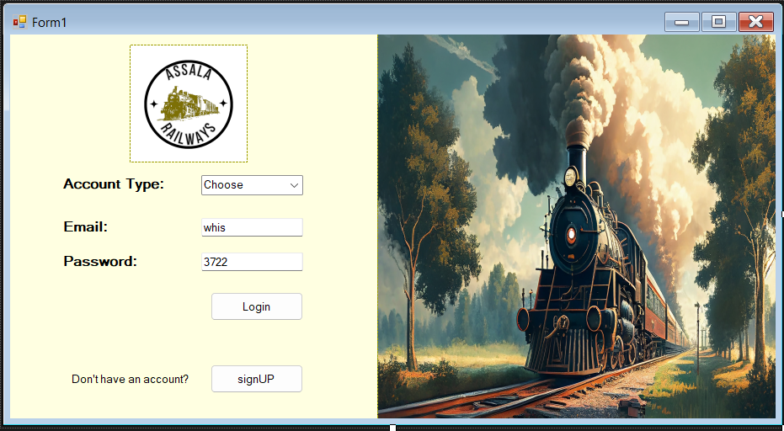**

**SIGNUP UI  
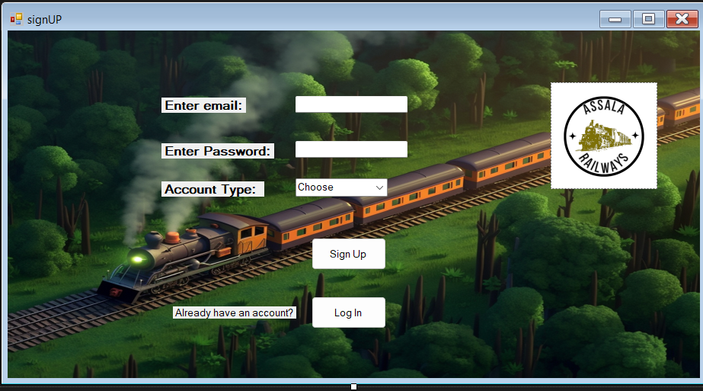  
ADMIN UI  
Dashboard  
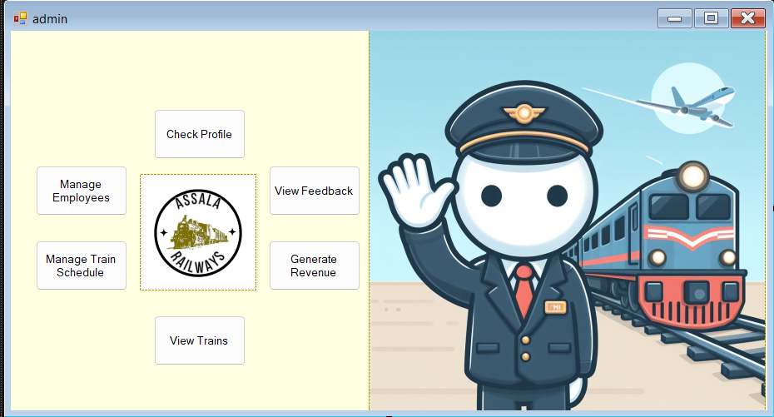  
Profile  
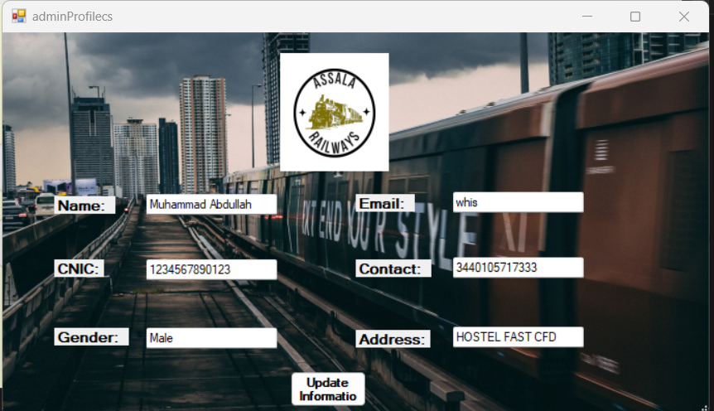**

**Manage Employees  
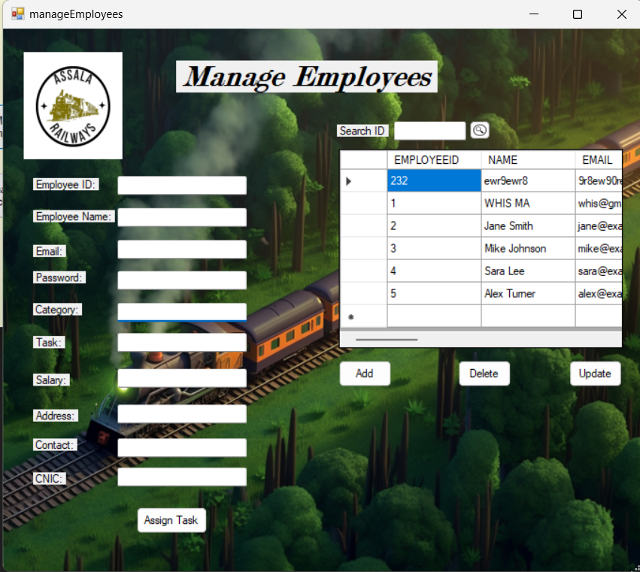**

**Manage Train schedule**

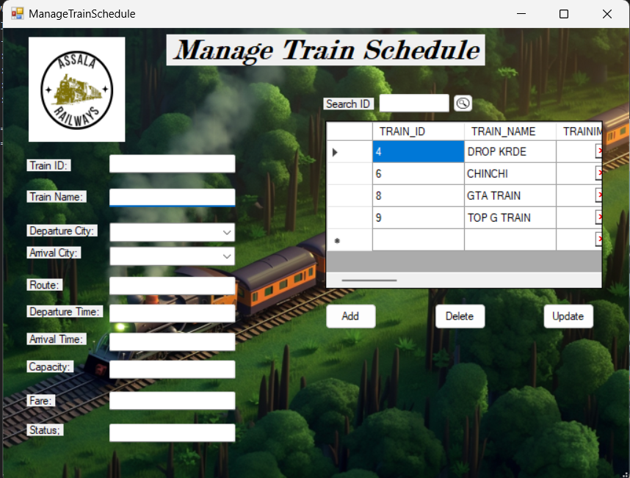

**VIEW TRAIN  
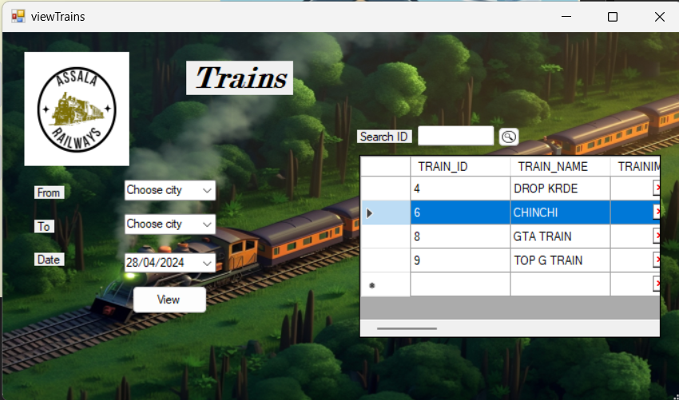**

**View Feedback  
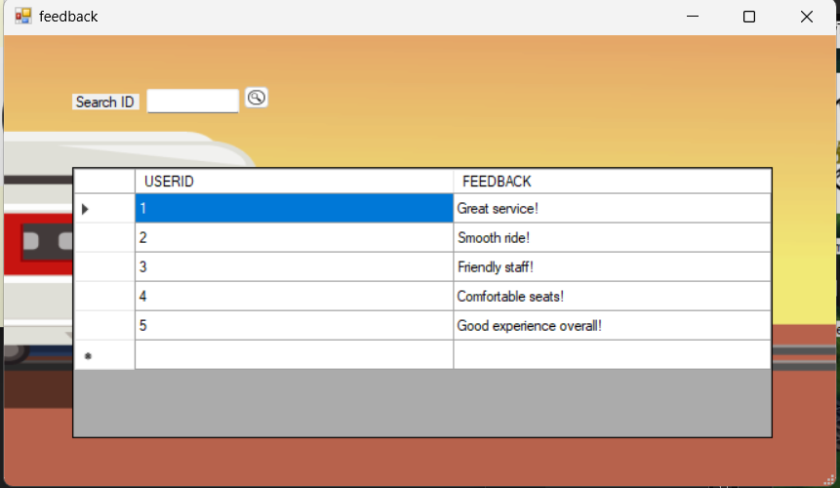**

**Employee UI  
Ticket Sell  
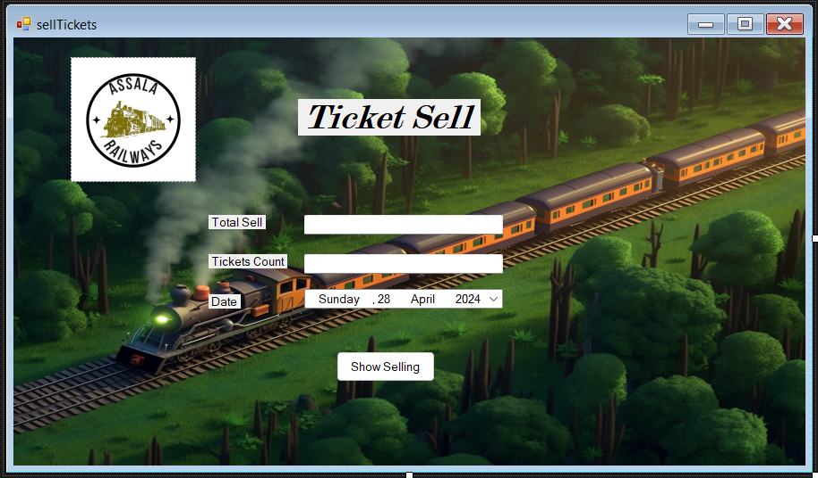**

**To Do List  
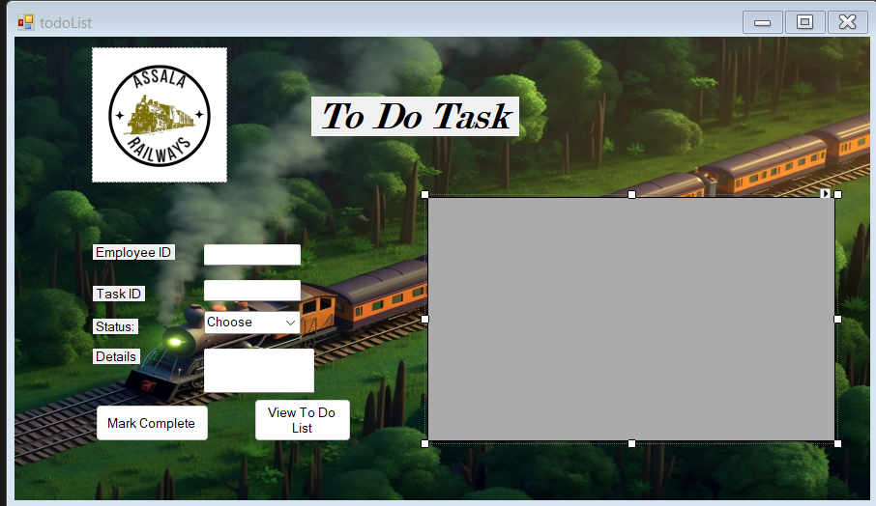**

**Salary  
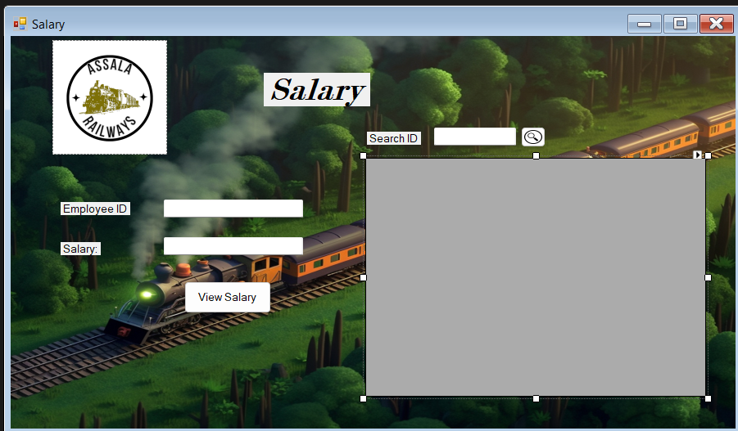  
Customer Support  
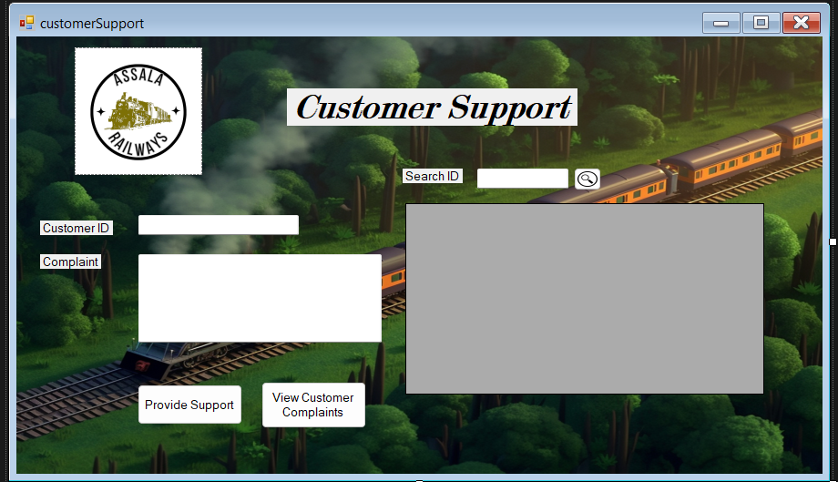**

**Check Profile**

**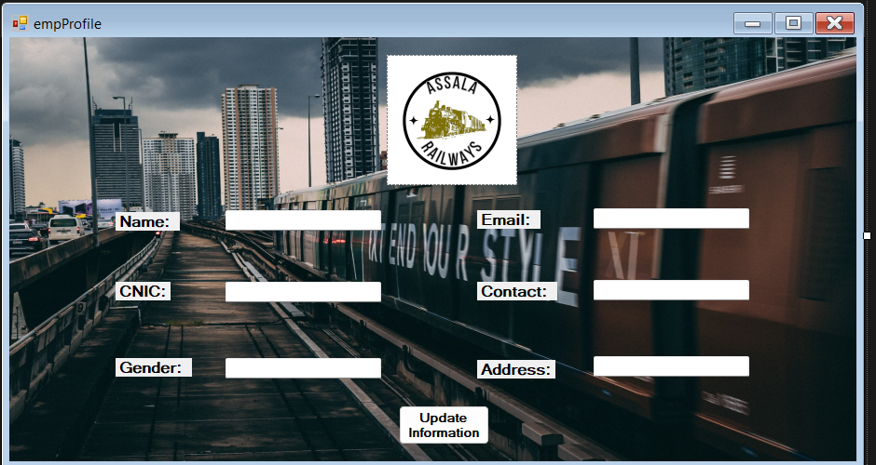  
Passenger UI  
Send Feedback  
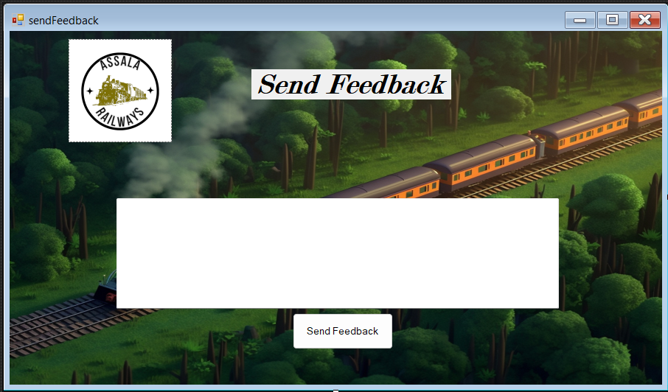**

**Track Train  
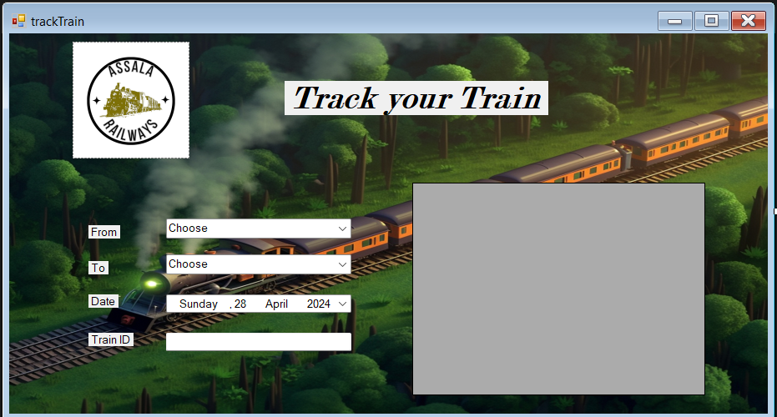**

**Previous Reservation  
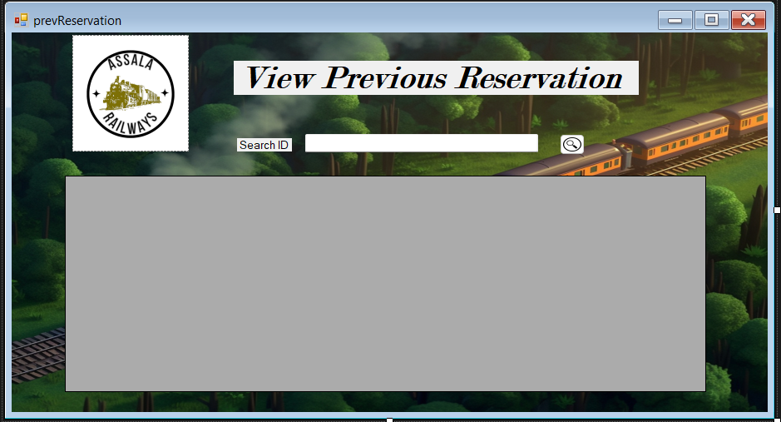**

**Book Seat  
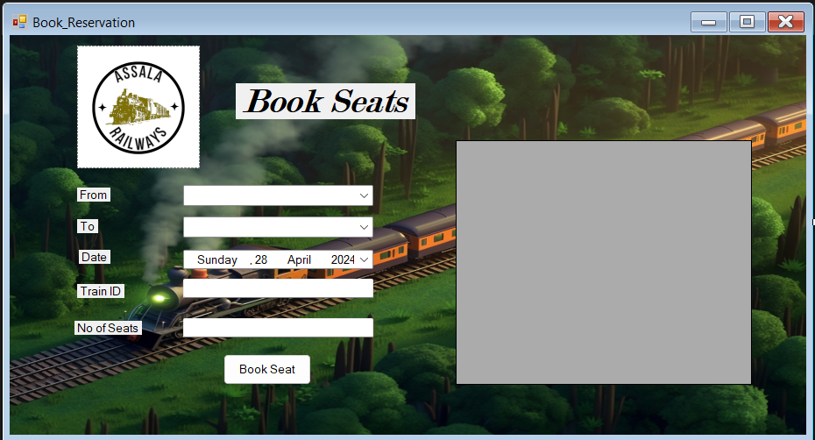  
Check Profile**

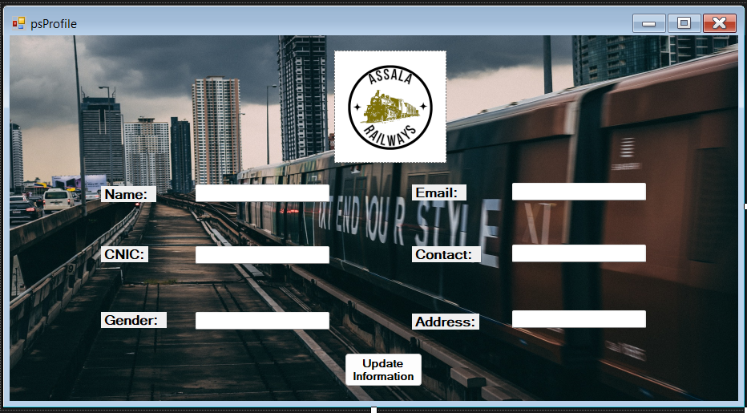

**Tables from DB  
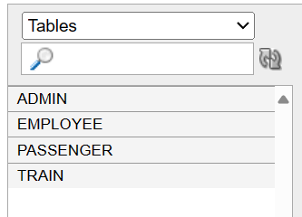**

**Admin  
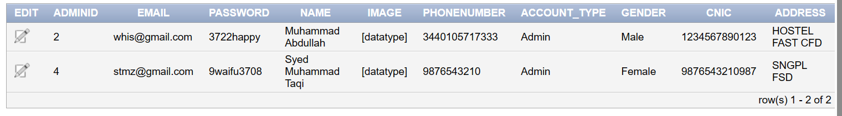**

**Employee**

**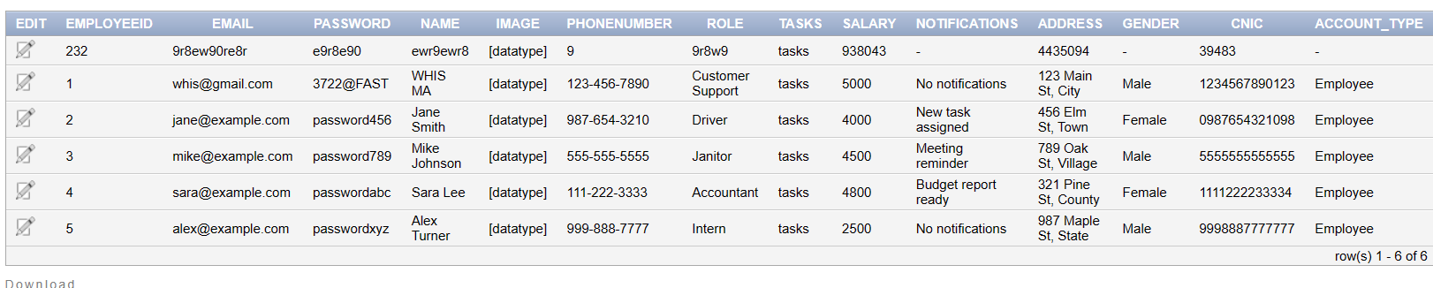  
Passenger**

**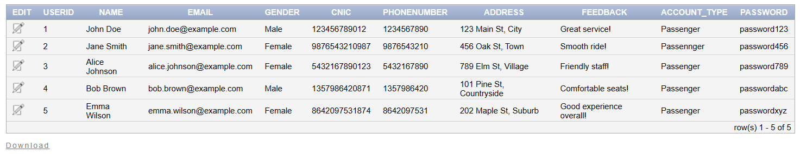  
Train  
